**Bahria University, Lahore Campus**

Department of Computer Sciences

Lab Journal 14

**(Fall 2023)**

|  |  |  |
| --- | --- | --- |
| Course: | **Database Management System Lab** |  |
| Course Code: | CSL 220 | Max Marks: 40 |
| Faculty’s Name: |  | Lab Engineer: |

Name: __AFFAN AHMAD_______ Enroll No: _03-134221-003______________________

**Transaction**

**Task 1**

## Objective:

The objective of this lab session is to learn Transactions and Concurrency in DBMS.

By the end of this lab students will be able:

* To implement the concepts of transactions in DBMS.
* To understand the concepts of concurrency in DBMS.

## Lab Tasks

**TASK 1:** **How to perform committing in Transactions and Concurrency**

Sol: BEGIN TRAN

insert into CUSTOMERS value (20,'sadia', 24, 'xyz' ,'70000' )

COMMIT TRANSACTION

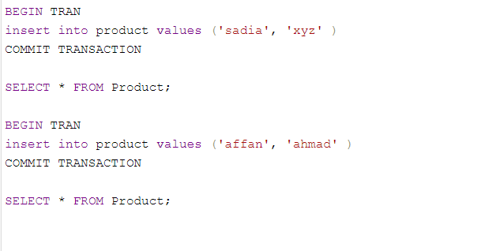

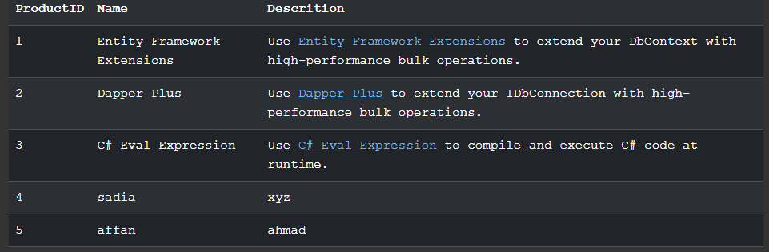

**Task 2: Write query for rollback in Transactions and Concurrency.**

Sol: BEGIN TRAN

insert into CUSTOMERS values (21,'sadia', 24, 'xyz' ,'70000' )

Select * from CUSTOMERS where NAME = 'sadia'

ROLLBACK TRANSACTION

Select * from CUSTOMERS where NAME = 'sadia'

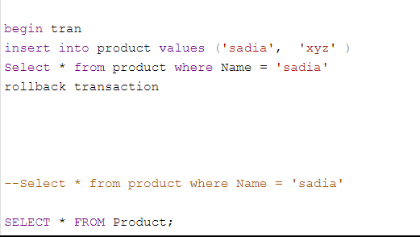

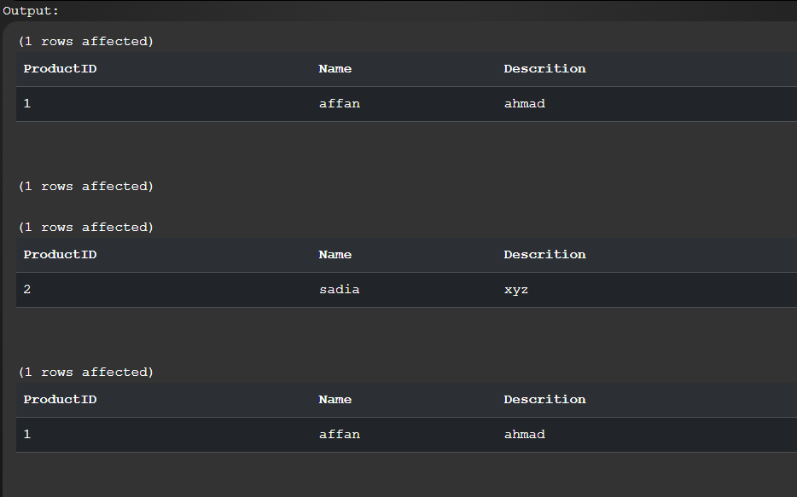

**Task 3: How to Naming Transaction in Transactions and Concurrency.**

Sol: BEGIN TRAN

insert into CUSTOMERS values

(23,'sadia', 24, 'xyz' ,'70000' )

Commit Tran AddSadia

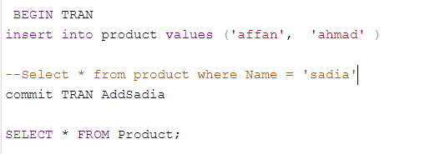

**Task 4: How to write query for Commiting and rollback conditions in Transactions and Concurrency.**

Sol: Declare@AddSadia INT

BEGIN TRAN

insert into CUSTOMERS values (24,'sadia', 24, 'xyz' ,'70000' )

Select @AddSadia= count(*)

from CUSTOMERS where NAME ='sadia'

IF @AddSadia >1

BEGIN

ROLLBACK TRAN AddSadia

Print 'Sadia Already there'

END

ELSE

BEGIN

Commit Tran AddSadia

PRINT 'Sadia added to database'

END

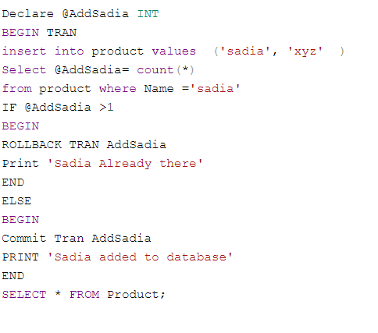

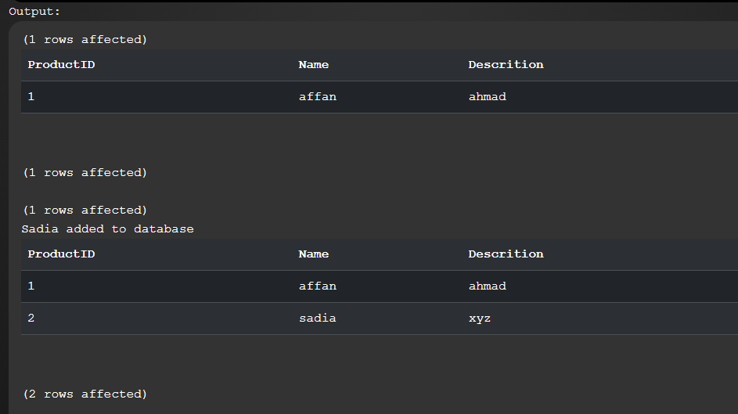

**Please explain each point what you understand.**

**Lab Grading Sheet**

|  |  |  |  |
| --- | --- | --- | --- |
| **Task** | **Max Marks** | **Obtained Marks** | **Comments(*if any*)** |
| 1. | 10 |  |  |
| 2. | 10 |  |  |
| 3. | 10 |  |  |
| 4. | 10 |  |  |
| **Total** | **40** |  | **Signature** |

**Note : Attempt all tasks and get them checked by your Lab Instructor**